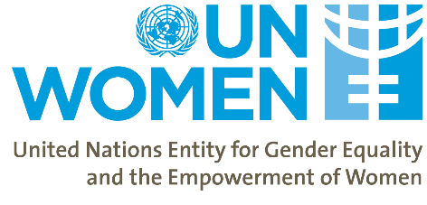
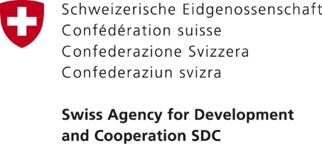
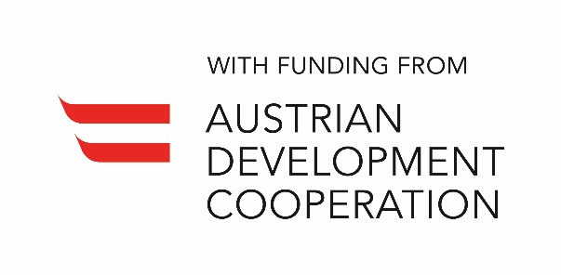

Analysis of the Gender Pay Gap Georgia

Date: | March 16, 2020
Location: | Ballroom 2, Courtyard Marriot Hotel, Tbilisi, Georgia
Organizers: | UN Women
Participants/target audience: | The event will bring together policy makers, private sector, trade unions and civil society participants from Georgia for the dissemination of the Gender Pay Gap analysis and to discuss the policy implications in Georgia.  Please find full list of invitees as part of the annexes (Annex 1).
Expected outcomes: | - Public dissemination of the country specific Gender Pay Gap analysis for Georgia. Participants will learn of the findings of the Gender Pay Gap analysis done by UN Women in collaboration with the GEOSTAT.  - Participants will discuss the role of various actors in address the GPG and discuss Georgian and international best practice

BACKGROUND
The conference is organized in the framework of the project “Women’s Economic Empowerment in the South Caucasus” (WEESC) funded by the Swiss Agency for Development and Cooperation (SDC) and Austrian Development Cooperation through the Austrian Development Agency (ADA) and implemented by UN Women. The objective of the conference is the provide a platform to discuss the Gender Pay Gap (GPG) in Georgia. The key target audience will be Government Ministries and Agencies, the Parliament and the private sector.

The event will gather representatives from the Parliament of Georgia, the government agencies that are involved in policy level decisions, data production and analysis on the GPG in Georgia (i.e. Ministry of Economy and Sustainable Development (MoESD) of Georgia; Department of Labour under the Ministry of Internally Displaced People from Occupied Territories, Labor, Health and Social Affairs (MoIDPOTLHSA) of Georgia and GEOSTAT. In addition, the event will include representatives from the Trade Unions and Employers associations of Georgia and key civil society organizations.
The programme will be divided into the following sections:
- Presentation on the study from Georgia
- Panel discussion on the role of various partners

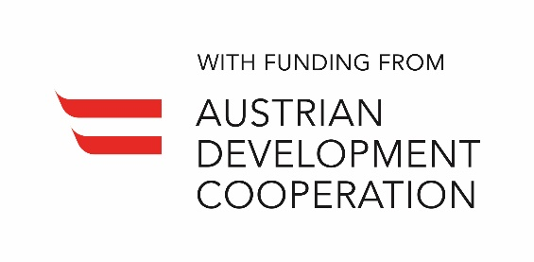

Women’s Economic Empowerment in the South Caucasus

Analysis of the Gender Pay Gap in Georgia

Venue: Ballroom 2, Courtyard Marriot Hotel, Tbilisi, Georgia

Date: 16 March 2020

Time: 14:00 – 16:30

Agenda
Time | Item
14:00-14:30 | Welcome coffee + Registration
14:30 – 15:30 | Opening session  Opening remarks  - Nino Tsilosani, Member of Parliament, Chair of the Gender Equality Council (TBC)  - Tamar Barkalaia, Deputy Minister of IDPs from the Occupied Territories, Labour, Health and Social Affairs of Georgia  - Danielle Meuwly, Regional Director, Swiss Cooperation Office for the South Caucasus  - Ambassador of Austria to Georgia (TBC)  Moderator: Tamar Sabedashvili, UN Women Deputy Representative, Georgia
14:30 – 15:30 | Presentation of study findings  - Decomposition of the Gender Pay Gap in Georgia – Marjan Petreski, Consultant, UN Women  Q&A session
15:30 – 16:30 | Presentation: Policy implications: addressing the Gender Pay Gap – Lia Jalaghania, Consultant, UN Women  Panel Discussion: Addressing the Gender Pay Gap – What are can be done?  Moderator: TBD  - Tamar Barkalaia, The Deputy Minister of IDPs from the Occupied Territories, Labour, Health and Social Affairs of Georgia  - Lela Akiashvili – Advisor to the Prime Minister of Georgia on Human Rights and Gender Equality Issues  - Representative of Georgian Trade Unions (TBC)  - Representative from Employers Association/Private Sector (TBC)  Q&A session  Closing remarks (UN Women)

Annex 1: Potential List of Participants
Government representatives
 | 3 person | Chair/Representatives of the Parliament Gender Equality Council
 | Lela Akiashvili | Inter-Agency Commission on Gender Equality and Violence against Women and Domestic Violence
 | Ekaterine Tikaradze | Minister of Internally Displaced Persons from Occupied Territories, Labour, Health and Social Affairs
 | Natia Turnava | Minister of Economy and Sustainable Development (MoESD)
 | 5 people | Ministry of Economy and Sustainable Development (MoESD)
 | 5 people | Ministry of Internally Displaced Persons from Occupied Territories, Labour, Health and Social Affairs (MoIDPOTLHSA) Department of Labour and Employment
 | 3 persons | GEOSTAT
 | 3 persons | Georgian Trade Union Confederation
 | 3 persons | Georgian Employers Association
 | 5 persons | Representatives of Private Sector
 | 5 persons | Civil Society Organizations
 | 5 persons | Media
Donor Organizations
 | Danielle Meuwly | SDC
 | Tamuna Tsivtsivadze | SDC
 | Austrian Ambassador | Embassy of Austria
 | Gerhard Schaumberger | ADA
 | Vakhtang Mshvidobadze | ADA
UN Representatives
 | Erika Kvapilova | UN Women Georgia
 | Mehjabeen Alarakhia | UN Women Georgia
 | Nani Bendeliani | UN Women Georgia
 | Ana Pashalishvili | UN Women Georgia
 | Mariana Unapkoshvili | UN Women Georgia
 | Olivia Schmitz | UN Women Georgia
 | Jenni Ratilainen | UN Women Georgia
 | Gvantsa Asatiani | UN Women Georgia
 | Nino Natroshvili | UN Women Georgia
 | Sabine Machl | UN RC
 | 3 persons | UNDP Georgia
 | 2 persons | ILO Georgia

